Logo%20Main%20200

**Boston University**

**Electrical & Computer Engineering**

**EC463 Capstone Senior Design Project**

**Problem Definition and Requirements Review**

Event Photography Module for Shark Vacuum Robot

Submitted to

SharkNinja | Brendan Uchendu

89 A Street Suite 100 

Needham, MA 02494

(617) 755-7611

BUchendu@sharkninja.com

by

Team 28

“Team 28”

Team Members

Sophia Delia sgdelia@bu.edu

Kevin Vasquez vasquezk@bu.edu

Alex Heaureaux-Perron alexchp@bu.edu

Liron Dubin ldubin@bu.edu

Brett Senders bsenders@bu.edu

Submitted: 10/14/2022

**Customer Sign-Off _______________________________________**

#### Event Photography Module for Shark Vacuum Robot

#### Table of Contents

**Event Photography Module for Shark Vacuum Robot** **2**

**Table of Contents** **2**

**Project Summary** **2**

**Need for this Project** **3**

**Problem Statement and Deliverables** **4**

**Visualization** **4**

**Competing Technologies** **5**

**Engineering Requirements** **6**

**Appendix A References** **6**

# Project Summary

As portable cameras and media sharing apps become more popular, there is an increased need for automated photo and video capture. Consumers want to document their experiences without being burdened by photography equipment or the costly expense of a photographer. At the same time, SharkNinja, maker of automated vacuum cleaners, seeks to expand their product line beyond cleaning. Our event photography module plugs into a SharkNinja robot, providing a user with an app-controlled, 360 degree field-of-vision “photographer.” The robot will use existing SharkNinja technology to map an event space, capture photos and videos of the area, and upload them to a database. Users will then access those photos and videos from an app, streamlining a seamless integration with other media platforms.

# Need for this Project

Consumer robotic vacuums have greatly improved since the first commercially successful model was released. No longer do they all operate by random navigation and rely on bumping into objects. Modern robotic vacuums, like the one developed by SharkNinja are now advanced mobile sensor suites, featuring LIDAR, room mapping, and obstacle avoidance. Despite these advances, their functionality remains limited to house cleaning. This limits their potential market as consumers may be reluctant to make a large investment for a single-purpose device.

The sophisticated sensors and controls of SharkNinja’s robot have the potential to transform the device into a flexible platform, enabling additional use-cases, and increasing the product’s value proposition to consumers. SharkNinja aims to take advantage of this platform through aftermarket accessory modules that expand the functionality of their vacuum robot beyond cleaning.

In the era of unmatched social media popularity, consumers are eager to capture content to share with their friends, family, and followers; Instagram alone has 700 million users [1]. It has also never been easier to capture moments on camera. Smartphones mean that nearly everyone has a high quality camera in their pocket capable of taking and storing nearly unlimited images.

For many, however, this ubiquity has taken the fun and novelty out of photo taking, where “If you don’t like the way the photo turned out, you can edit it, delete it or take as many pics as you have to to get that perfect shot — which can lose its value” [2]. In response, the popularity of disposable and instant film cameras, which were once considered obsolete, have exploded, especially among young people. Instant cameras are expected to grow 2.4% from 2021 to 2029 and disposable cameras 6.7% between 2022 and 2028 [3,4].

There is a clear demand for devices that take fun photos without significant input and which don’t overwhelm the user with choice. The app David’s Disposable which forces users to wait until 9 AM before they can even view their photos reached over a million downloads in just a few weeks of its release [5]. Many users describe the appeal of these old cameras and modern apps as allowing them to capture more “raw” and “candid” moments.

In particular, at events and parties, people may prefer to ‘live in the moment’ or have difficulty carrying a phone or camera, especially those in clothing without pockets, like dresses and women’s pants.

A party photography module for the SharkNinja robot will leverage the powerful sensor platform to automatically capture fun candid moments at events and parties with limited user input. Partygoers can simply enjoy an event or choose to pose when the robot drives by, and the device will capture images at all angles with a 360° camera which can be easily viewed and shared from a companion app afterwards. This module has the potential to greatly expand not only the functionality of SharkNinja’s robotic vacuum, but the potential market to a younger, socially-connected audience.

# Problem Statement and Deliverables

Consumers need the ability to passively capture and share media. Our solution will address both issues with a plug-in module, automated media capture, and photo and video sharing managed by an application. Current existing products are very expensive, and are often only available to rent. The SharkNinja module would cost less than $200. Further, the existing products are not autonomous, requiring constant user input; the devices are more similar to a photobooth than a photographer.

An existing challenge is the proposed product’s height. Since the robot’s LIDAR sensor can only detect objects at its “eye-level”, it often misses obstacles. In order to compensate for this, there is a bumper attached to the front of the robot. When the bumper presses into anything, the robot stops and changes course. The bumper function would need to extend the entire height of the module’s column, such that whenever the column collides with an obstacle, the robot knows to change course. Thus, a mechanical system that works in conjunction with the bumper must extend the entire height of the column.

The placement of the LIDAR dome on the stock robot poses another mechanical challenge. Since nothing can impede the vision of the LIDAR dome, it is likely that all structural support for the column will have to be entirely on top of the small dome. A threaded insert is not possible; altering the body of the robot is prohibited by the customer. One possible solution is to anchor the column using a suction or adhesive anchoring system. With this system, the column could be mounted in a single step.

Another challenge is the lack of access to SharkNinja source code. This means that any interfacing with the robot must be done with a secondary microcontroller, and the libraries that SharkNinja provides the team access to. With accessory microcontrollers come limited memory and high latency. Code written and programmed to a microcontroller will never be as fast or take up as little space as code that is as close to the existing hardware as possible.

With the module enabled, the robot will act as a completely autonomous photographer. It will be able to follow people throughout events and take candid photos and videos of them. Users will have access to all of the photos and videos while the robot is being used and after it is docked. All media will be uploaded to a cloud-database, with sufficient storage for multiple uses of the robot.

# Visualization

The product will consist of two parts: the column and the plug-in module. The column will be mounted to the top of the LIDAR dome, and stand at a height of four feet tall. At the top of the column there will be a mount for a 360 degree field-of-view camera. Finally, there will be a ring light around the camera. This ring light can be controlled by the app, and will have the ability to be always on, always off, or in a flash enabled mode.

Along the column will be a mechanical system to interact with the bumper on the stock robot. Since the robot’s LIDAR can only detect obstacles at its height, the bumper will be crucial to avoid collisions with objects taller than the robot itself, such as couches or tables.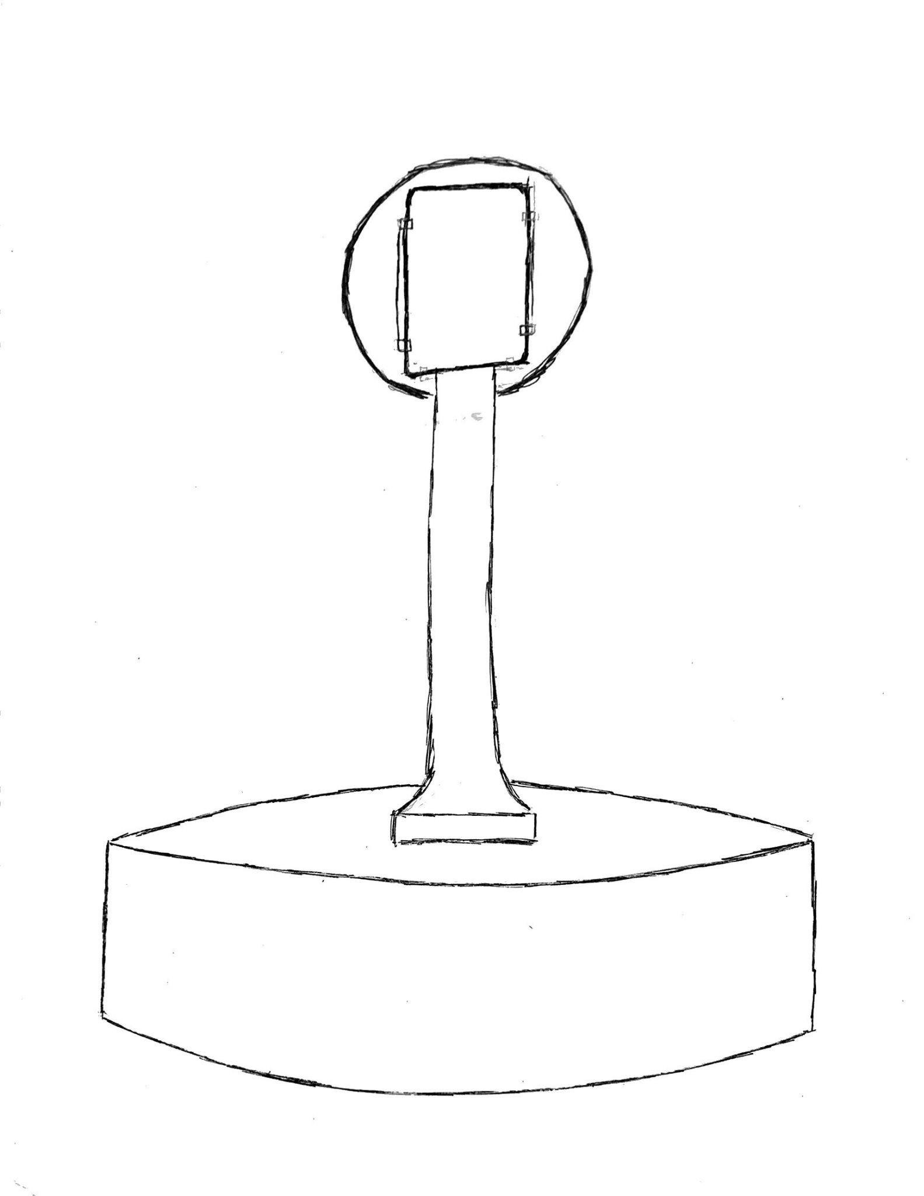*Figure 1: Sketch of robot with camera column, camera held in designated mount, and ring light for illuminating subjects*

A companion app is the main user interface. The app will show where each photo or video was taken during an event, and allow the user to download that media. A floorplan view with a dot or heat map will enable the user to explore the images captured throughout the event space.

All media will be stored in a cloud-based database. The control app will access that database, and allow users to download photos from their respective event.

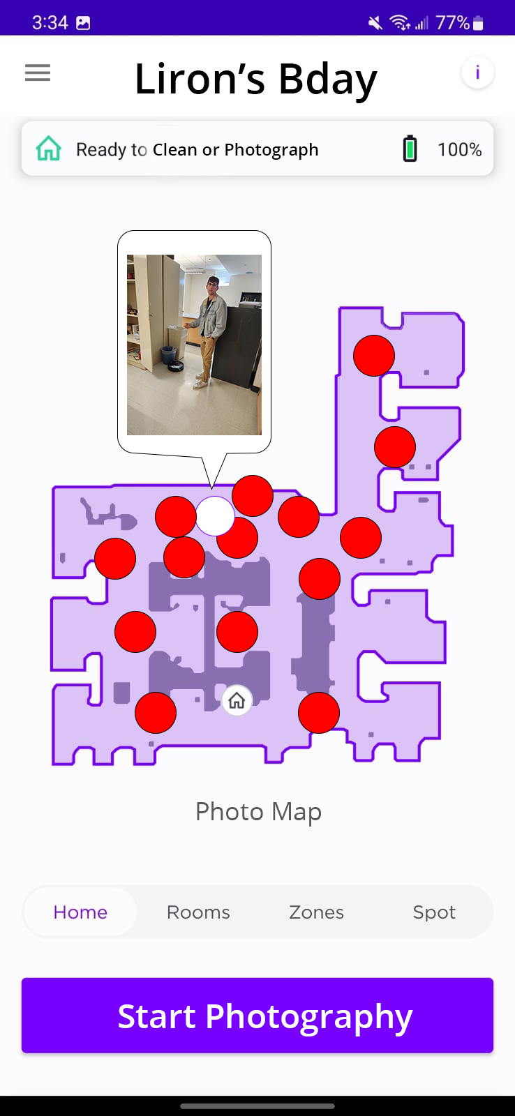

*Figure 2: Mock-up of app for controlling camera-robot and viewing media capture location*

# Competing Technologies

Competing companies, such as Viral Booth Creative Events, specialize in products that function similarly to the SharkNinja module. Viral Booth’s product traverses rooms and acts as a mobile picture booth. Unlike the SharkNinja module, Viral Booth’s product requires user input [6]. The SharkNinja module is different: it is completely autonomous after it leaves the charging booth, and therefore has the ability to take candid event photos. Further, the SharkNinja module is intended to be bought, not rented like Viral Booth’s product [7] . At $6,500, the Viral Booth photo robot is too expensive for most consumers (Atlanta Photo Booth) [7]. The SharkNinja module will be no more than $200, a price that more consumers can afford.

A competing technology to Shark’s proposed module platform is iRobot Create. Rather than a system of accessories intended for consumers, this is an educational and research platform. Because the platform is specific to iRoboto Roombas, it can not be used with Shark robots [8].

# Engineering Requirements

The customer requires that the product must work as a plug-and-play accessory to SharkNinja’s production model vacuum robot. The design cannot rely on hardware modifications to the robot, and any components of the design that exist outside of the device’s module compartment (e.g. the proposed camera column) must be attached non-destructively and removably. The plug-in module must also be simple for customers to install. Assembly must have less than five steps and not require tools.

The module must work with the robot, and the robot must roam a party and capture 360° images. To provide the desired functionality, the module must be able to communicate with the robot and trigger a routine for it to move throughout its mapped area. The module will need to communicate with the robot using its app and existing communication protocols, as it will not have access to the robot’s source code. The module must trigger the camera (or cameras) to capture at a set interval. In addition, the device must be able to store captured media in one of two ways: by storing media locally, then uploading to a cloud-based storage service after capture, or by capturing, then uploading to cloud-database immediately after.

A companion application will be needed for the user to trigger the photography routine, enter settings (such as flash configuration), and view photos. If multiple cameras are used, the app must stitch pairs of images into single 360° images that can be cropped by the user into the desired framing.

In order to fully cover a party or event, the robot should be able to capture images for at least 30 minutes without recharging. The added load placed on the robot must not exceed 15 lbs. The LIDAR dome cannot be obstructed in a way that interferes with the robot’s navigation, mapping, or obstacle avoidance. The camera column must be equipped with obstacle detection, so that the robot knows if the column has hit something above the bumper and outside LIDAR visibility.

# Appendix A References

[1] E. Musonera, “Instagram: A Photo Sharing Application,” *Journal of the International Academy for Case Studies*, vol. 24, no. 4, pp. 1–9, 2018.

[2] L. Mahan, “Youngsplaining: Why Are So Many Young People Obsessed With Disposable Cameras?” InsideHook. <https://www.insidehook.com/article/internet/why-are-young-people-using-disposable-cameras> (Oct. 14, 2022).

[3] R. and Markets, “Worldwide Instant Print Camera Industry to 2029 - Asia Pacific to Register the Fastest Growth,” *GlobeNewswire News Room*, Apr. 04, 2022.<https://www.globenewswire.com/news-release/2022/04/04/2415586/28124/en/Worldwide-Instant-Print-Camera-Industry-to-2029-Asia-Pacific-to-Register-the-Fastest-Growth.html> (Oct. 14, 2022).

[4]“Disposable Camera Market Size, Growth, Global Trends, Forecast to 2028.”<https://www.fnfresearch.com/disposable-camera-market> (Oct. 14, 2022).

[5] A. Mak, “The Insanely Popular App That Mimics Those Flimsy Disposable Cameras From the 90s,” Slate. <https://slate.com/technology/2020/01/davids-disposable-app-iphone-camera-ios.html> (October 14, 2022).

[6] “Robot Photo Booth - Roving Around Your Party,” *Viral Booth OC*.<https://viralboothoc.com/robot-photo-booth/> (Oct. 14, 2022).

[7] “Atlanta Photo Booth.” <https://atlantaphotobooth.com/the-rover-robotic-photo-booth/> (accessed Oct. 14, 2022).

[8] M. Dekan, L. Chovanec, A. Babinec, and A. Vitko, “New Modules for the iRobot Create Platform,” *Procedia Engineering*, vol. 48, pp. 65–72, Jan. 2012, doi: [10.1016/j.proeng.2012.09.486](https://doi.org/10.1016/j.proeng.2012.09.486).

[9] G. Shirakyan, “Method, apparatus and system for an autonomous robotic photo booth,” US US10694097B1, Jun. 23, 2020.

[10] R. R. Ondeck, G. Cozen, C. L. Miller, G. Williams, and M. Mandel, “Recording and entertainment system,” US9666194B2, May 30, 2017.

[11] パックロバート トッド et al., “可動式ロボットシステム,” JP6039611B2, Dec. 07, 2016.

[12] “The Rise, Fall, and Revival of Polaroid: The Instant Photography Icon,” PetaPixel.<https://petapixel.com/2021/08/25/the-rise-fall-and-revival-of-polaroid-the-instant-photography-icon/> (Oct. 14, 2022